Welcome to the first Walton Parish Council newsletter for 2022.
Changes to the Parish Council Chair of the Parish Council Liz Fairclough retired in December after serving as Chair for 20 years and as a Councillor for 31 years. Parish Councillors attended her leaving presentation and were joined by West Yorkshire Police's Sergeant Matthew Jackson, and Chief Superintendent Mark McManus who presented Liz with a certificate for her work on the Safe Scheme. In 1997 Liz was responsible for initiating Wakefield’s first Safe Scheme in Walton. Many Parish Councils followed our lead as a result. As part of the Parish Council, Liz was involved in numerous projects over the years including setting up of Walton Colliery Nature Park, originally The Wetlands, along with Yorkshire Water and WMDC. She also helped to oversee the new playground in Walton Park, the housing development on the old school site on School Lane, Walton stone boundary signs and the Neighbourhood Plan.
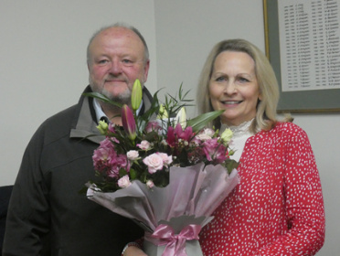
Following Liz’s retirement John Carlon was nominated and unanimously voted in as new Chair by Parish Councillors. Vice Chair Keith Shaw, Chris Wagstaff and Philip Lee have recently resigned, and we thank them all for their work and dedication to Walton village. Chris Pearson was nominated and unanimously voted in as new Vice Chair. Tanya Earnshaw and Steve Barker were co-opted to join the Parish Council at the March meeting.
New Chair of Walton Parish Council John Carlon presenting flowers to Liz Fairclough
John Carlon says” Liz will be a hard act to follow after 30 years as a Councillor and Chair. Whilst I shall not serve as long, I hope to progress the projects the PC have ongoing at present to look after the assets of the village such as the tennis club, Coronation Cottage the recreation ground and Jubilee Field. I want to ensure the Sports and Social Club can maintain the sports they run now and enhance the facilities. The village has some great facilities and initiatives run by local residents and parishioners, businesses and volunteers and if the Parish Council can help in any way, please contact one of us. I will continue to protect the rights of way, Walton Colliery Nature Park and ensure the village open space is maintained with nature at the top of the list working with my fellow Councillors and many friends in the village. When I was little running up to the old primary school to beat the headmaster into school, I never thought one day I would be in the same village all these years later.”
Meet the Councillors – Part 2
Chris Pearson Vice Chair
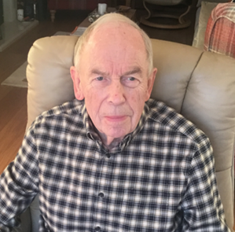
We moved to Walton eight years ago and I became a member of the Parish Council. Since that time, I have taken an active role on various working parties. It was good to be involved in the up grading of the recreation equipment and the Park generally. I have recently become Vice Chair of the Council and look forward to being involved in a range of new initiatives which will further enhance the village and benefit the local community.

Sheila Leith
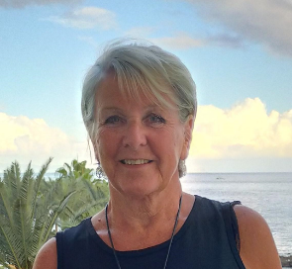
Hi, I’m Sheila Leith and have lived in Walton for 28 years. I was delighted to be co-opted onto the Parish Council three and a half years ago. I am keen to improve facilities for the people of Walton by working with my fellow Councillors and other volunteer groups in the village. I retired 14 years ago from the NHS after working as a Primary Care Development Manager, helping to improve GP services in the local area. I then volunteered as a listener with the Samaritans and when the Library in Walton was closed by Wakefield Council, I helped to set up Walton Community Library. My responsibilities on the Parish Council include Floral Displays, Footpaths plus the Village Hall and Tennis Club working parties. I am also a member of the Staffing Committee.

Hot topics from recent Parish Council meetings Floral Displays The Parish Council were disappointed to learn a number of decorative Christmas trees couldn't be hung on lamp posts as planned last year, we are working closely with WMDC and our supplier to ensure we have an alternative design for Christmas this year. We are however, delighted to confirm that the beautiful summer floral displays will once again grace the main roads in the village. Anyone wishing to sponsor a hanging basket should contact the Parish Clerk. (See details overleaf) Traffic issues On Tuesday 30th November 30+ residents attended a follow up meeting to discuss traffic issues. Wakefield Council Highways Department shared ideas of possible ways to slow down traffic throughout the village. A second traffic survey is planned to record number and speed of traffic on major roads. Information around the “20 is plenty” scheme is being sourced and will be shared in due course. We have been updated by Councillor Maureen Cummings who is receipt of an email from Wakefield Highways Department confirming that School Lane will be resurfaced in the first half of this year. Trees in the Recreation Ground The tall Leylandii trees surrounding the tennis courts shed a great deal of darkness on the play area in the recreation ground. It is planned to remove these this year making the seating area a more pleasant place to sit and meet friends in the park. There will also be some pruning work carried out on trees around the perimeter of the park as advised by Wakefield Council’s Tree officer. Tennis Courts Following a consultation in 2020 regarding the future of the tennis courts and pavilion, a Parish Council working group is putting together plans for redevelopment of this area. There has been delay due to the continuing uncertainty around the possible move of West Yorkshire Sports and Social Club to Brook Farm on Shay Lane. Watch this space, we will keep you posted. Precept The Parish Precept of £38,000. will remain the same this year. The amount to be paid for a property in Council Tax Band D is £32.40. Parish Council Grants Recipients of successful grant applications of £250, are Friends of Waterton’s Wall, Walton Primary Academy Garden Club/Walton PTA and Walton Primary Academy Governors.
Village news Walton Library and Charles Waterton House Official Opening Weekend -starts Friday 25 March. Live music, family activities and chance to meet a well-known local Author. Further details to follow.
Friends of Waterton’s Wall - 2026 marks the bicentenary of the completion of Squire Charles Waterton’s wall around his estate. It is the site of the first nature reserve in the world. This wall has both historic and scientific importance not just locally but nationally. This three-mile wall, which took Waterton some 5 years to build, is now falling into disrepair. The Friends of Waterton’s Wall has been established with the aim to: Identify and preserve a section of the wall surrounding Charles Waterton’s estate and promote its upkeep and story. The first project ‘Waterton’s Wall 2026’ has the aim is to preserve a section of wall to celebrate its 200th anniversary in 2026. The public launch of the project will be on Tuesday 29 March in the Village Hall at 7.30pm. We look forward to seeing you. Queens Jubilee Weekend- There are plans to host a Diamond Jubilee Party in Walton on Thursday 2nd June. Please save the date! Walton Open Gardens is a biennial event for Walton Community Library (registered charity 1154607). This year it will take place on Sunday 3 July when we hope that >15 gardens around our beautiful village will be open to visitors. There will be food and drink to buy, ice creams (of course) plus many other opportunities to support our brand-new library. Previously we have raised in excess of £11, 000 and we hope to substantially increase that after the cancellation last year’s Open Gardens. Please contact John Smith: phone: 07779 641655 or email: gardens@smoaklands.com if you are interested in being involved by: volunteering on the day or being a financial supporter (there are lots of ways of doing this)
The Annual Parish meeting will be held on Tuesday 5th April from 6.30pm until 7.15pm. This is a great opportunity for residents to pop along and join this annual forum to discuss and share anything relating to the village. The next 3 Parish Council meeting dates are: April 5th, May10th and June 7th

